King Fahd University of Petroleum & Minerals



College of Computer Science and Engineering

Information and Computer Science Department

First Semester 161 (2015/2016)

ICS 202 – Data Structures

Major Exam 2

Monday, December 12th, 2016

Time: 90 minutes

Name: _______________________________________________

|  |  |  |  |  |  |  |  |  |  |
| --- | --- | --- | --- | --- | --- | --- | --- | --- | --- |
| ID# |  |  |  |  |  |  |  |  |  |

|  |  |  |  |  |
| --- | --- | --- | --- | --- |
|  |  | Question # | Max Marks | Marks Obtained |
|  |  | 1 | 20 |  |
|  |  | 2 | 20 |  |
| Section 02 |  | 3 | 20 |  |
| Dr. Sami |  | 4 | 20 |  |
|  |  | 5 | 20 |  |
|  |  |
| 10-10:50am |  | Total | 100 |  |

**Instructions**

1. **Write your name and ID in the respective boxes above and circle your section.**
2. **This exam consists of 9 pages, including this page, plus one reference sheet, containing 6 questions.**
3. **You have to answer all 6 questions.**
4. **The exam is closed book and closed notes. No calculators or any helping aids are allowed.**
5. **Make sure you turn off your mobile phone and keep it in your pocket if you have one.**
6. **The questions are not equally weighed.**
7. **The maximum number of points for this exam is 100.**
8. **You have exactly 120 minutes to finish the exam.**
9. **Make sure your answers are readable.**
10. **If there is no space on the front of the page, feel free to use the back of the page. Make sure you indicate this in order not to miss grading it.**

**Q.1 (20 points: 2x10):** Consider the following tree:

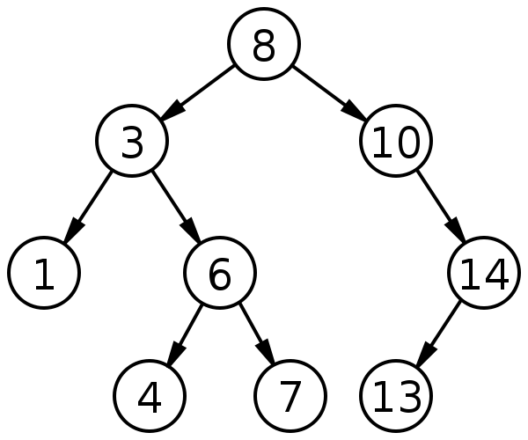

1. List the nodes of the left subtree of the root:
2. List the ancestors of node 6:
3. List the proper descendants of node 10:
4. What is the degrees of nodes 8, 1, and 14 respectively?
5. List all internal nodes of the above tree:
6. Are nodes 6 and 14 siblings?

1. What are the levels of nodes 8,14, and 7 respectively?
2. What are the heights of the trees whose root are: 3, 14, and 8 respectively?
3. Is the above tree full or complete?
4. Is the above tree a BST, balanced, perfectly balanced?

**Q.2: (20 points)** AVL Trees

Consider the following AVL Tree

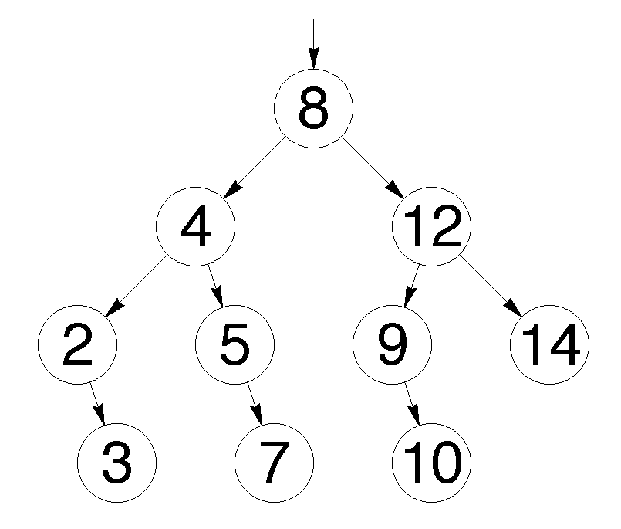

Draw the AVL Tree after each one of the following operations (4 x 5 = 20 points)

Insert(2.5)

Insert(7.5)

Insert(9.5)

Delete(5), Delete(7)

**Q.3: (20 points)** Binary Heaps

Consider the following MinHeap

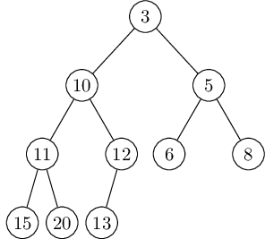

Draw the minHeap after each one of the following operations (4 x 5 = 20 points)

Enqueue(5)

Enqueue(1), Enqueue(2)

Dequeue()

Dequeue(), Dequeue()

**Q.4: (20 points)** B+ Trees

Consider the following B+ Tree where M=3 and L=3



Draw the B+ Tree after each one of the following operations (4 x 5 = 20 points)

Insert(14)

Insert(25)

Delete(26)

Delete(33), Delete(31)

**Q.5: (20 points)**  Considering the number of additions (+), write the recurrence relation of each of the following methods and compute the big O complexity of each one of them:

1. int recursiveFun1(int n)

{

if (n <= 1)

return 1;

else

return 1 + recursiveFun1(n/5);

}

b) int recursiveFun2(int n)

{

for (i = 0; i < n; i += 2) {

// do something

}

if (n <= 0)

return 1;

else

return 1 + recursiveFun2(n-5);

}

**Quick Reference Sheet**

 ,  , , 

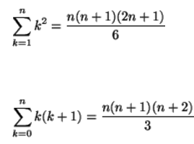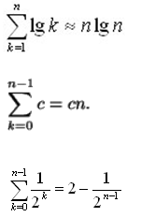HarmonicSeries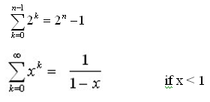geometricSeries